Comprehensive Linux Operations

Project Breakdown

Part 1: Creating and Editing text files

1. Used nano and created a text file server_config.txt and added the text

2. Next Edited text of the same file using the ‘vi’ command
Appended the text: Installed Packages: Apache, MySQL, PHP

3. Next used vim command to edit the file
vim server_config.txt
Appended the text: “Configuration Complete: Yes”

Screenshot of the terminal:

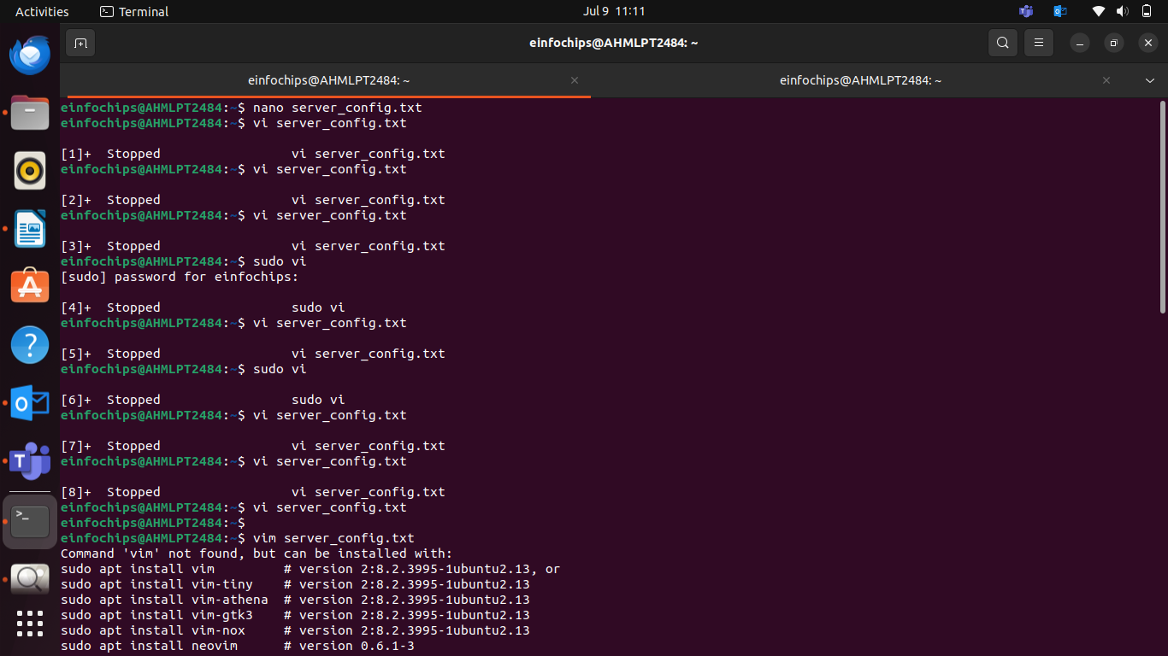
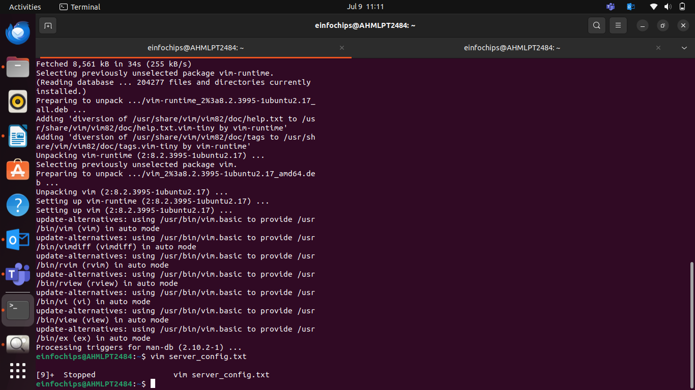
Screenshot of the server_config.txt file in nano:

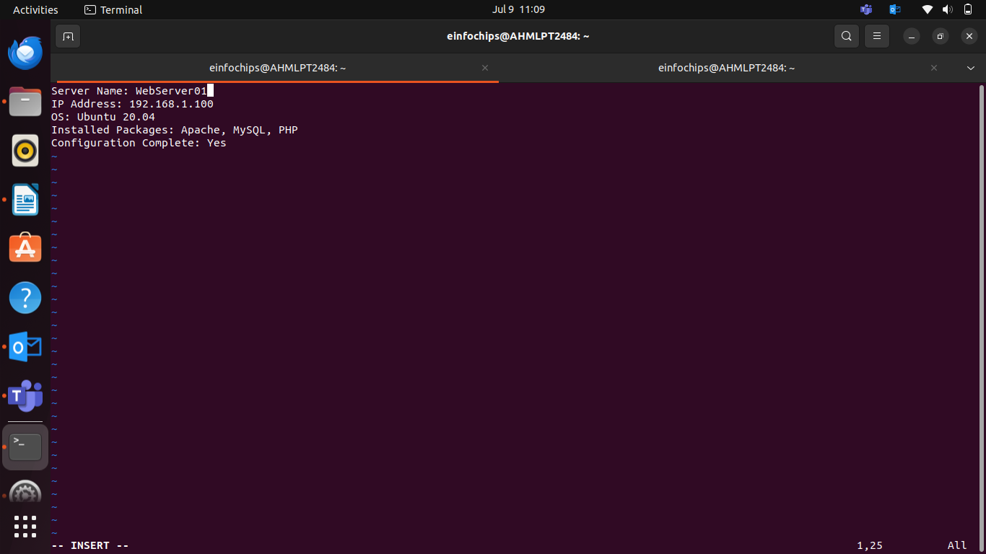

Part 2: User & Group Management

1. Added and Removed User

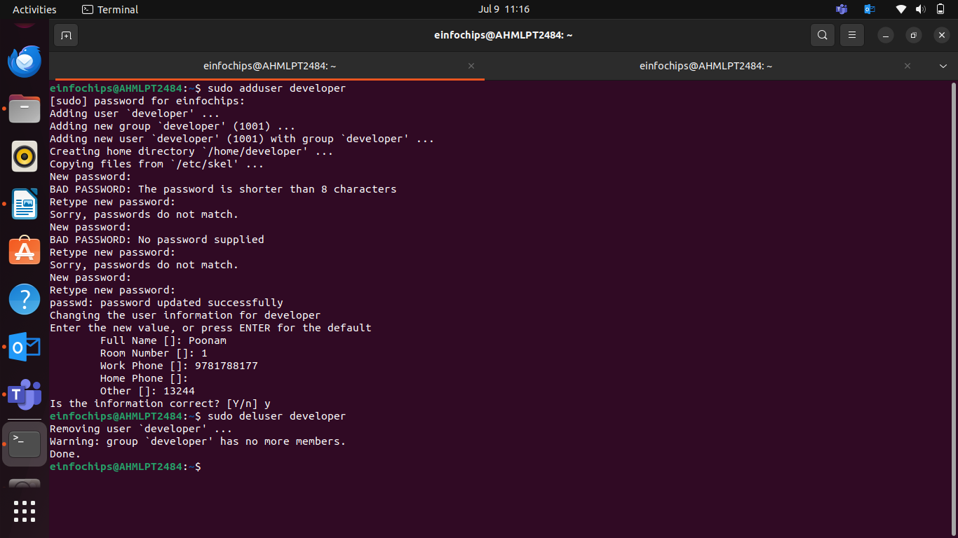
2. Managing groups

Created a group devteam
Added a user and removed the user named developer from the devteam

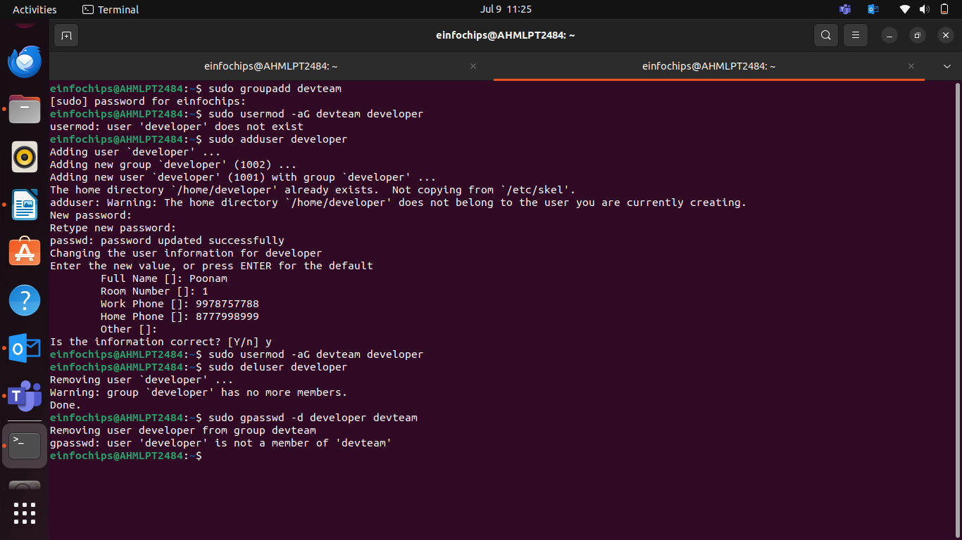

Part 3: File Permissions Management

Understood the file permissions and changed the file permissions

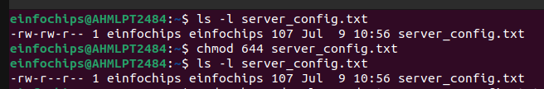
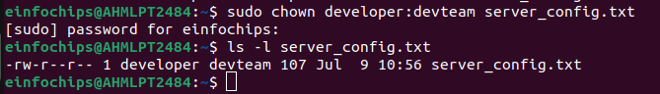
Part 4: Controlling Services and Daemons

1. Managing Services with systemctl

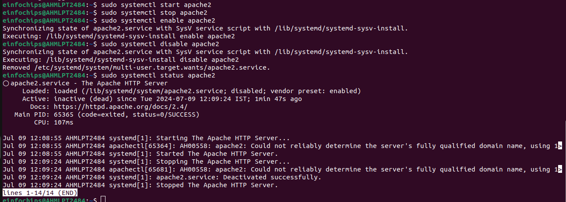
2. Understanding Daemons

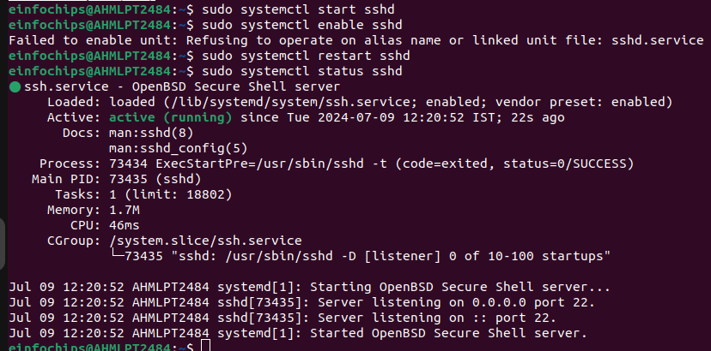
Part 5: Process Handling

1. Viewing Processes

ps aux
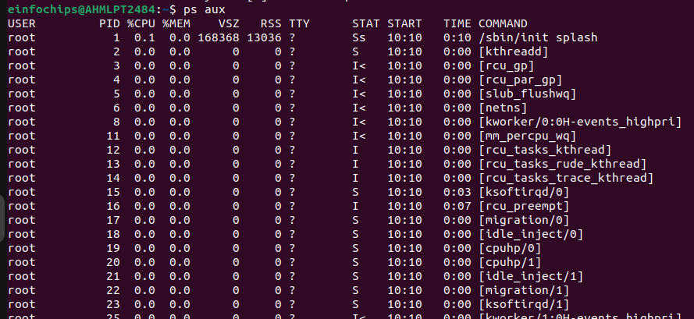

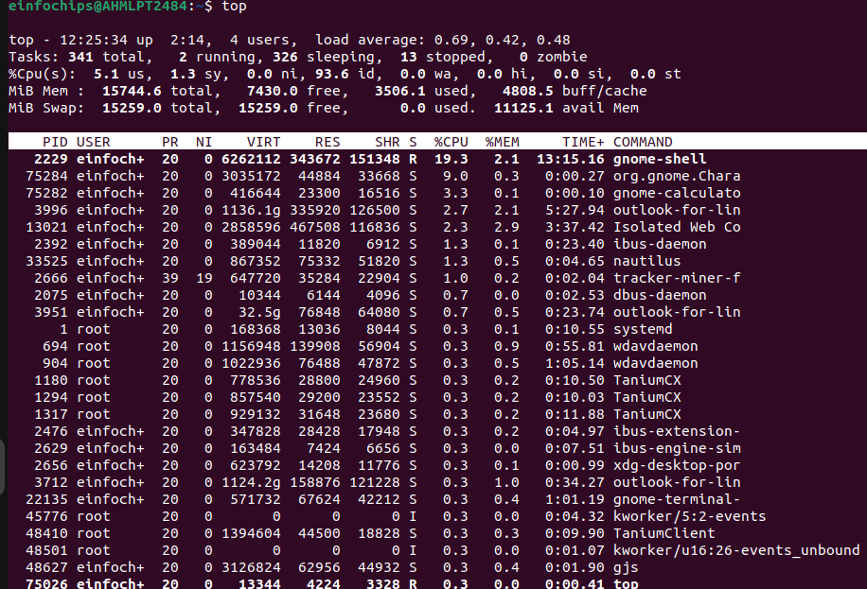
2. Used top to view process in real time.

Creating and Deploying a Static Website with Apache2
Part 1: Installing Apache2

Started and enabled Apache2 which gave the Apache2 Default page as an output on the localhost page.

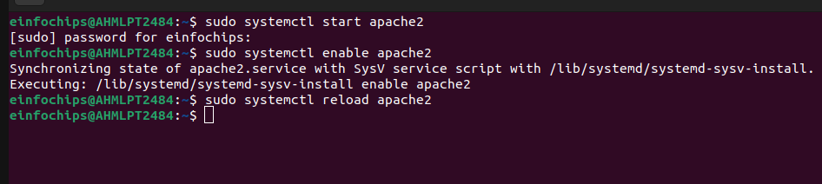
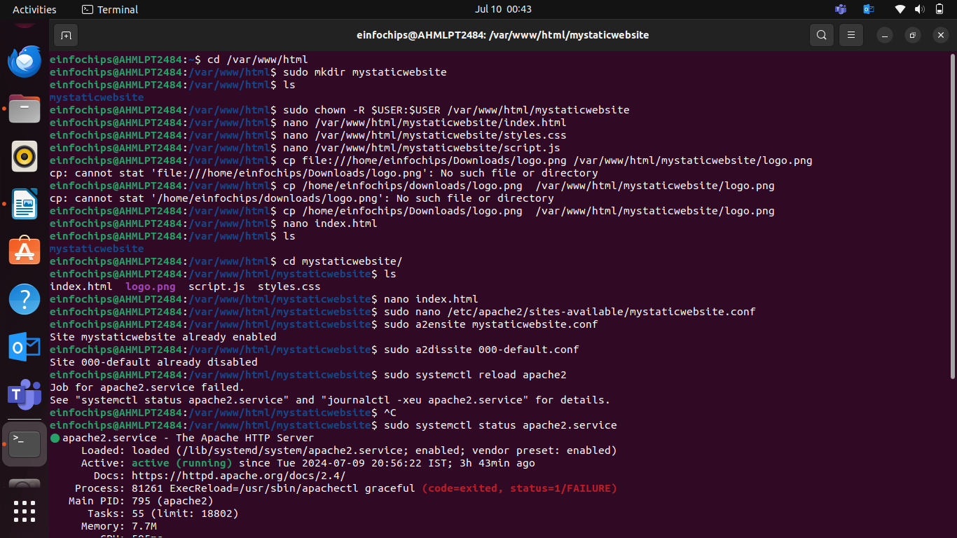

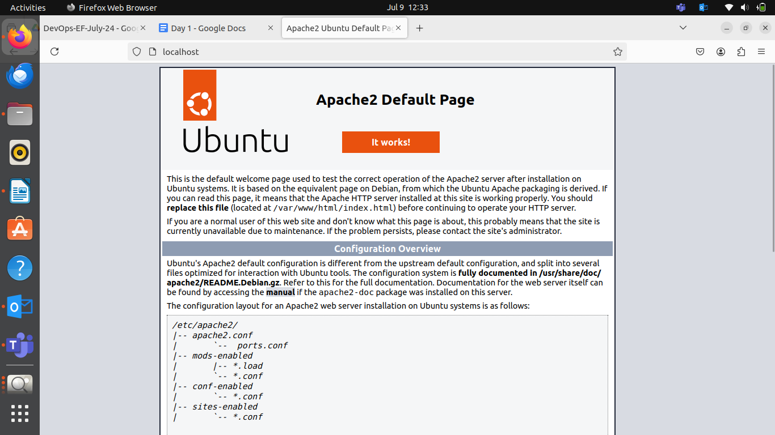
Part 2: Creating the Website

Made a web directory and navigated to the web root directory.

- Navigate to the Web Directory
Change to the web root directory:
cd /var/www/html

- Create a New Directory for the Website
Create a directory named mystaticwebsite:
sudo mkdir mystaticwebsite

Change ownership of the directory:
sudo chown -R $USER:$USER /var/www/html/mystaticwebsite

- Create HTML File
Create and edit the index.html file:
nano /var/www/html/mystaticwebsite/index.html

